ISES WIS pilot project
Update 15 March 2015
Mike Terkildsen
(m.terkildsen@bom.gov.au)
Background
The 2013 ISES meeting (Action 8) agreed to pursue a project within ISES, and working with WMO, to explore the use of the WMO Information System (WIS) for the exchange of space weather products. The aims of the project were to improve our understanding of the WIS architecture and operations, identify any benefits or limitations of data exchange through the WIS for the space weather community, and the feasibility of this kind of data exchange, and to achieve this by establishing the operational exchange of a small subset of space weather parameters through the WIS. The initial set of products identified for trial data exchange were solar and geomagnetic activity observations and forecasts. Possible exchange data formats were explored and, by way of example, a draft BUFR data format was compiled for a solar activity observation and forecast product.
The ISES 2014 meeting reviewed the draft BUFR format and recommended other data formats also be explored, in particular XML, which is somewhat less complex, widely used within the aviation industry and more recently adopted by WMO for provision of products to the aviation industry (eg the newly defined WMO AvXML schema).
In December 2014 it was decided to pursue exchange of an XML-format solar flare probability product as the initial product for the pilot project. A draft XML schema for solar flare probability was developed for the CCMC solar flare forecast scoreboard project, a project on which a number of ISES representatives have actively participated. This product was reviewed and adopted for the WIS pilot project. An example of the XML-format probabilistic solar flare forecast product can be found in Appendix A.

Implementation
As an established WMO DCPC for Space Weather, Space Weather Services (SWS) within the Australian Bureau of Meteorology (BoM) has the necessary WMO approval to contribute products to the WIS. At the present technical state of the DCPC implementation however, this capability has not yet been established. The alternative approach is to register as a user on a GISC and establish an agreement with the GISC to contribute data. BoM operates GISC Melbourne, and since SWS is internal to the BoM, this kind of formal agreement is not required. SWS is able to contribute directly as a registered user to GISC Melbourne, simply through internal data transfer to the BoM server handling the WIS GISC interface.
To support the WIS pilot project, software was written to generate the XML-format forecast product from BoM/SWS solar activity forecast models. The software was integrated into BoM/SWS operations in February 2015. Generation of the product at 6-hourly intervals (00, 06, 12, 18UT) commenced on 06 March 2015. At the BoM/SWS, the forecast product is linked to a series of data-driven statistical models for solar flare probabilities however the source of the forecasts populating the XML product is not further relevant to the WIS pilot.

Metadata
One key aspect of the WIS is the definition of precise and informative Discovery Access and Retrieval (DAR) metadata associated with each product. The aim of the metadata is to allow WIS users to quickly and accurately locate a product or a range of products using the search and discovery capability of WIS. The metadata definition for WIS products should be based on the WMO Core metadata profile (current version 1.3) which is in turn derived from and consistent with ISO standards ISO 19115 and ISO 19139.
Metadata consistent with the WMO Core profile was defined for the BoM probabilistic solar flare forecast product in February 2015, and registered on WIS. This was achieved using the metadata generation tool built into the OpenWIS WIS interface adopted by GISC Melbourne. An XML representation of the metadata can be found in Appendix B. While some aspects of the metadata are specific to the BoM product, the general form and content of the metadata could be readily adapted to any agency contributing solar flare forecasts to the WIS in the CCMC standard format.
Key aspects of the metadata are the abstract, and the keywords used for discovery, shown below:
Abstract:
The product contains probabilistic forecasts of X-ray solar flare activity expected to occur within a 24 hour period following the forecast issue time.
The forecast probabilities pertain to the full visible solar disk and/or discrete active regions on the Sun. The probabilities relate to flaring at each of two magnitude levels:
1. M-class or greater flares (peak flux in 1-8Å band exceeding 10⁻⁵ W/m²)
2. X-class or greater flares (peak flux in 1-8Å band exceeding 10⁻⁴ W/m²).
The forecasts are generated by the Australian Bureau of Meteorology every six hours at 0000UT, 0600UT, 1200UT, 1800UT, by combining statistical models of solar flare activity with forecaster input.
The forecast product is in XML format.

Keywords:
"SpaceWeather" (theme)
"solar X-ray flare activity" (theme)
"Sun" (place)

Access through WIS
The BoM solar flare forecast metadata are available through WIS, including the request and subscription functions (see instructions below). The forecast products themselves are currently populating a development OpenWIS system within the Bureau for testing, and will be made available on the external WIS by mid April. The data is physically stored in the GISCs rather than simply specifying a link to an external data source. On registration, the product was listed for global exchange meaning it will be synced between GISCs and therefore become available through any GISC around the world. The process for accessing the product through the various GISCs may vary. We describe below the process for accessing the product through GISC Melbourne. GISC Melbourne has adopted the OpenWIS implementation and interface for WIS. The process for accessing the product through other GISCs with the same OpenWIS implementation should be identical; other GISCs may have their own proprietary WIS interface, however access and subscription procedures should be comparable.
The following procedure is required to access and subscribe to BoM probabilistic solar flare forecasts through the OpenWIS interface of GISC Melbourne (note: Please use a modern browser! Some older versions of IE do not seem to work).
- Find the GISC Melbourne web interface. In your internet browser, go to the OpenWIS interface to GISC Melbourne at wis.bom.gov.au (or type “WIS BoM” into Google)
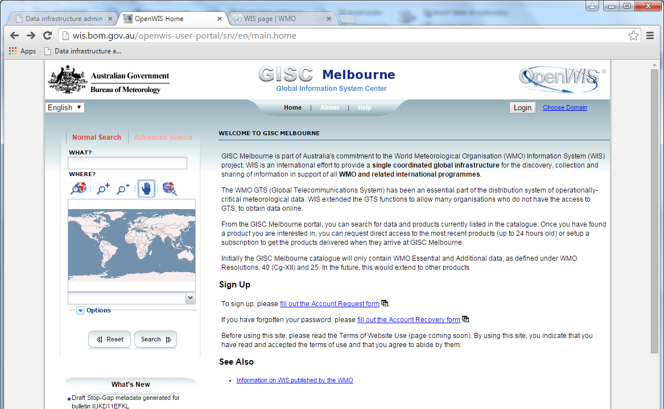

- Register as a user. To subscribe to products available through the WIS, you must sign up as a user (click "fill out the Account Request form" on main page). This can take a few hours to process. Once approved, use initial login details to log in to the WIS interface.

- Find the solar flare product. The OpenWIS interface has an in-built search and discovery tool. For the solar flare product, one can simply search on “solar flare”. A summary of products matching the search terms should then be displayed. Currently there is only one solar flare related product, which is the BoM product. At this point, one can view the full metadata associated with this product, or a subset thereof, or view the latest available product, or (if signed in) subscribe to the product.
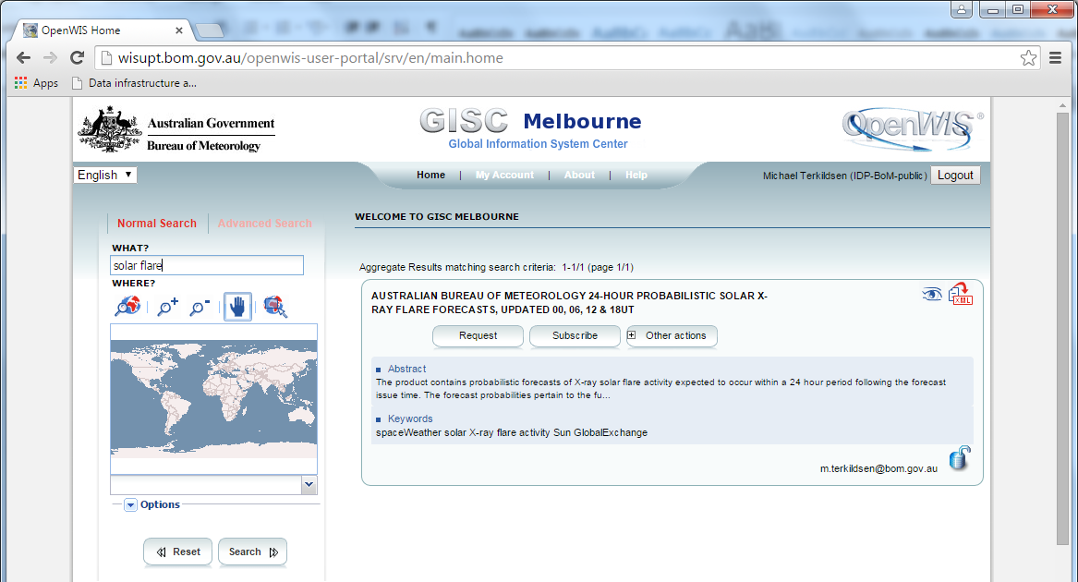

- Establish a subscription to the product. Select "Subscribe" on the displayed product. Subscription to a product establishes the automated delivery of that product to a given user by the WIS. The OpenWIS interface allows multiple modes of delivery of products once subscribed. The delivery mode is defined at the point of subscription, but may be modified at any time. Products can be delivered based on a fixed time schedule, or whenever the product is updated on WIS. OpenWIS allows delivery of the product via email (either inline or as an attachment); through a ‘staging post’ which may be accessed via the WIS interface or via FTP; or the product may be delivered to an FTP address defined at the point of subscription.
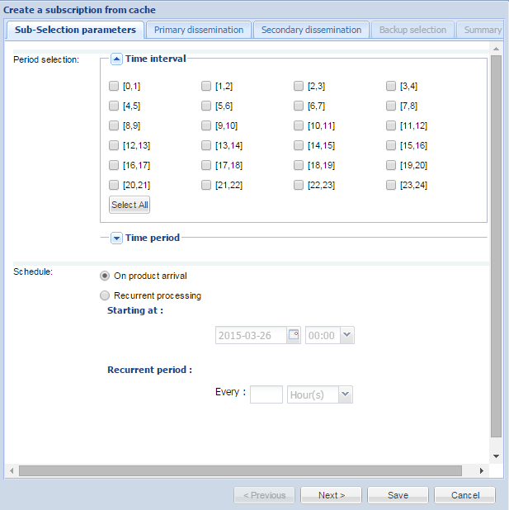 | 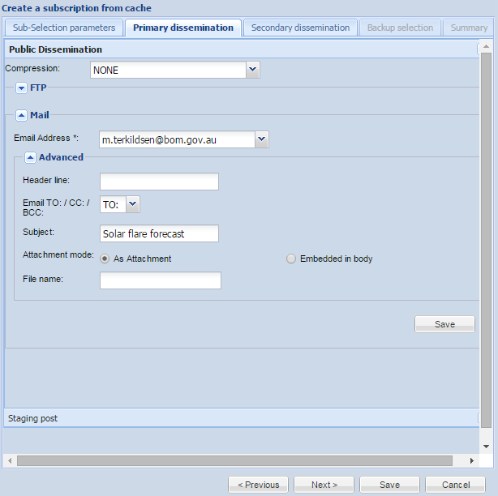
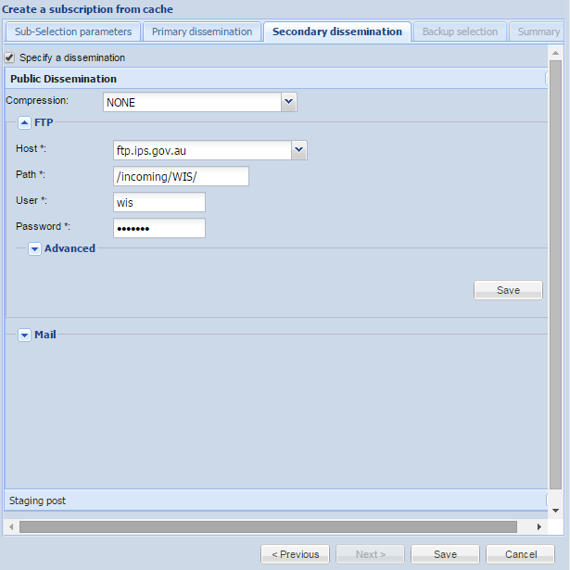

In the case of the solar flare forecast product, this product is generated every six hours out of the Australian Space Forecast Centre (ASFC). To test the efficacy of the system, we have also signed up the ASFC as an independent user, and currently receive the BoM solar flare forecast every six hours as an email attachment. We are in the process of implementing and testing a data handling capability to utilise forecast products delivered via the WIS. Once other RWCs commence contributing solar flare forecasts to WIS in the same manner, these can be added to the subscription and seamlessly handled within the ASFC.
Please note (updated 07 April): Due to delays in transitioning the OpenWIS data handling for the solar flare forecast data from the development to the production system within BoM OpenWIS, the forecast product will now begin populating the WIS in mid April (estimated). Subscriptions are still valid and once new data are added to WIS, "on arrival" subscriptions through GISC Melbourne OpenWIS should automatically forward on the new data.
Next steps
The BoM solar flare forecast marks the first space weather product contributed to the WIS under the pilot project. Through establishing this capability, the project team have gained an insight into the architecture and operation of the WIS, the requirements and procedures for contributing to, and accessing data from the WIS. However, the BoM experience is not completely representative of what is required to become a regular contributor to the WIS, since BoM/SWS is both favourably located within a National Meteorological Agency (BoM) that is currently operating a GISC (Melbourne), and BoM/SWS are a currently designated DCPC for Space Weather (albeit without a completely implemented technical capability for WIS interface). The next step should be to translate the BoM experience to other RWCs with different relationships to their NMA.
Related to this, one of the key recommendations made following the WMO ICTSW/5 meeting was the need to encourage RWCs to commence a dialogue with their nearest WIS GISC with a view to establishing formal arrangements for the future contribution of space weather data to the WIS. The key here is that RWCs need not be established as DCPCs to contribute data or forecasts to WIS (being a registered user on a GISC should be sufficient), although in the longer term there may be benefits in doing so. Given the delays in establishing these kinds of dialogues this was recommended to be progressed as a matter of some priority.
We should also encourage RWCs and other users to start accessing the trial products through the WIS. The aim will be to identify both limitations as well as benefits of accessing and utilising space weather products through the WIS.
Finally, we should look to expand the set of trial products exchanged through the pilot project. Initially, the project team decided on solar and geomagnetic activity forecasts as the priority products. Related to ISES Action 2014/7 RWC Australia would like to propose that we re-consider this, and instead consider adopting the following products as a higher priority. These products are not space weather forecast products, but key observational and alert products that directly inform forecasts made by RWCs, so in that sense they are aimed more an inter-RWC exchange rather than provision of forecasts to end users:
- Solar active region parameters (NOAA #, area, magnetic class, Zurich class,++): These parameters are used in data-driven (or even 'manual') solar flare probability forecasts. Timeliness is the key with this data, with daily updates too old to accurately inform the models.
- "PRESTO" alerts for Type II radio sweeps and CME detections: These alert products are (arguably) the key alert products that are not widely available (other than through URSIgram "PRESTO").

Appendix A – XML-format probabilistic solar flare forecast product (example)
<?xml version="1.0"?>
<message>
<forecast property="solarflareoccurance">
<method>Australian Bureau of Meteorology, Space Weather Services Flarecast automatic forecast</method>
<issuetime>2015-03-26T00:00Z</issuetime>
<predictionwindow>
<starttime>2015-03-26T00:00Z</starttime>
<endtime>2015-03-27T00:00Z</endtime>
</predictionwindow>
<input_data>----</input_data>
<group>
<forecasttype>Region</forecasttype>
<sourceregion>
<id scheme="NOAA_AR_numbering_scheme">2303</id>
<location time="2015-03-25T00:00Z">N19W30</location>
</sourceregion>
<entry>
<fluxbin name="M"/>
<probability>
<value>0.01</value>
</probability>
</entry>
<entry>
<fluxbin name="X"/>
<probability>
<value>0.01</value>
</probability>
</entry>
</group>
<group>
<forecasttype>Region</forecasttype>
<sourceregion>
<id scheme="NOAA_AR_numbering_scheme">2305</id>
<location time="2015-03-25T18:18Z">S08E32</location>
</sourceregion>
<entry>
<fluxbin name="M"/>
<probability>
<value>0.26</value>
</probability>
</entry>
<entry>
<fluxbin name="X"/>
<probability>
<value>0.02</value>
</probability>
</entry>
</group>
<group>
<forecasttype>Region</forecasttype>
<sourceregion>
<id scheme="NOAA_AR_numbering_scheme">2307</id>
<location time="2015-03-25T00:00Z">S19W04</location>
</sourceregion>
<entry>
<fluxbin name="M"/>
<probability>
<value>0.01</value>
</probability>
</entry>
<entry>
<fluxbin name="X"/>
<probability>
<value>0.01</value>
</probability>
</entry>
</group>
<group>
<forecasttype>Full Disk</forecasttype>
<sourceregion/>
<entry>
<fluxbin name="M"/>
<probability>
<value>0.34</value>
</probability>
</entry>
<entry>
<fluxbin name="X"/>
<probability>
<value>0.03</value>
</probability>
</entry>
</group>
</forecast>
</message>

Appendix B – XML-format metadata for probabilistic solar flare forecast product
<?xml version="1.0" encoding="UTF-8"?>
<gmd:MD_Metadata xmlns:mdbase="http://www.bom.gov.au/wis/mdbase" xmlns:gts="http://www.isotc211.org/2005/gts" xmlns:gmx="http://www.isotc211.org/2005/gmx" xmlns:xsi="http://www.w3.org/2001/XMLSchema-instance" xmlns:gml="http://www.opengis.net/gml/3.2" xmlns:gmd="http://www.isotc211.org/2005/gmd" xmlns:gco="http://www.isotc211.org/2005/gco" xsi:schemaLocation="http://www.isotc211.org/2005/gmd http://www.ngdc.noaa.gov/metadata/published/xsd/schema/gmd/gmd.xsd http://www.isotc211.org/2005/gmx http://www.ngdc.noaa.gov/metadata/published/xsd/schema/gmx/gmx.xsd">
<gmd:fileIdentifier xmlns:gml="http://www.opengis.net/gml">
<gco:CharacterString>urn:x-wmo:md:au.gov.bom::solar-flare-forecast</gco:CharacterString>
</gmd:fileIdentifier>
<gmd:language>
<gco:CharacterString>eng</gco:CharacterString>
</gmd:language>
<gmd:characterSet>
<gmd:MD_CharacterSetCode codeList="" codeListValue=""/>
</gmd:characterSet>
<gmd:parentIdentifier>
<gco:CharacterString/>
</gmd:parentIdentifier>
<gmd:hierarchyLevel>
<gmd:MD_ScopeCode codeList="http://www.isotc211.org/2005/resources/codeList.xml#MD_ScopeCode" codeListValue="series"/>
</gmd:hierarchyLevel>
<gmd:contact>
<gmd:CI_ResponsibleParty>
<gmd:individualName gco:nilReason="missing">
<gco:CharacterString/>
</gmd:individualName>
<gmd:organisationName>
<gco:CharacterString>Space Weather Services - Australian Bureau of Meteorology</gco:CharacterString>
</gmd:organisationName>
<gmd:positionName gco:nilReason="missing">
<gco:CharacterString/>
</gmd:positionName>
<gmd:contactInfo>
<gmd:CI_Contact>
<gmd:phone>
<gmd:CI_Telephone>
<gmd:voice>
<gco:CharacterString>+61 2 9213 8000</gco:CharacterString>
</gmd:voice>
<gmd:facsimile>
<gco:CharacterString>+61 2 9213 8060</gco:CharacterString>
</gmd:facsimile>
</gmd:CI_Telephone>
</gmd:phone>
<gmd:address>
<gmd:CI_Address>
<gmd:deliveryPoint>
<gco:CharacterString>PO Box 1386</gco:CharacterString>
</gmd:deliveryPoint>
<gmd:city>
<gco:CharacterString>Haymarket</gco:CharacterString>
</gmd:city>
<gmd:administrativeArea>
<gco:CharacterString>NSW</gco:CharacterString>
</gmd:administrativeArea>
<gmd:postalCode>
<gco:CharacterString>1240</gco:CharacterString>
</gmd:postalCode>
<gmd:country>
<gco:CharacterString>Australia</gco:CharacterString>
</gmd:country>
<gmd:electronicMailAddress>
<gco:CharacterString>office@ips.gov.au</gco:CharacterString>
</gmd:electronicMailAddress>
</gmd:CI_Address>
</gmd:address>
<gmd:onlineResource>
<gmd:CI_OnlineResource>
<gmd:linkage>
<gmd:URL>www.ips.gov.au</gmd:URL>
</gmd:linkage>
<gmd:protocol gco:nilReason="missing">
<gco:CharacterString/>
</gmd:protocol>
<gmd:name gco:nilReason="missing">
<gco:CharacterString/>
</gmd:name>
<gmd:description gco:nilReason="missing">
<gco:CharacterString/>
</gmd:description>
</gmd:CI_OnlineResource>
</gmd:onlineResource>
</gmd:CI_Contact>
</gmd:contactInfo>
<gmd:role>
<gmd:CI_RoleCode codeList="http://www.isotc211.org/2005/resources/codeList.xml#CI_RoleCode" codeListValue="pointOfContact"/>
</gmd:role>
</gmd:CI_ResponsibleParty>
</gmd:contact>
<gmd:dateStamp>
<gco:DateTime xmlns:gml="http://www.opengis.net/gml">2015-03-04T05:39:11</gco:DateTime>
</gmd:dateStamp>
<gmd:metadataStandardName>
<gco:CharacterString>WMO Core Metadata Profile of ISO 19115 (WMO Core), 2003/Cor.1:2006 (ISO 19115), 2007 (ISO/TS 19139)</gco:CharacterString>
</gmd:metadataStandardName>
<gmd:metadataStandardVersion>
<gco:CharacterString>1.3</gco:CharacterString>
</gmd:metadataStandardVersion>
<gmd:identificationInfo>
<gmd:MD_DataIdentification>
<gmd:citation>
<gmd:CI_Citation>
<gmd:title>
<gco:CharacterString>Australian Bureau of Meteorology 24-hour probabilistic solar X-ray flare forecasts, updated 00, 06, 12 & 18UT</gco:CharacterString>
</gmd:title>
<gmd:date>
<gmd:CI_Date>
<gmd:date>
<gco:Date>2015-02-24</gco:Date>
</gmd:date>
<gmd:dateType>
<gmd:CI_DateTypeCode codeList="http://www.isotc211.org/2005/resources/codeList.xml#CI_DateTypeCode" codeListValue="creation"/>
</gmd:dateType>
</gmd:CI_Date>
</gmd:date>
<gmd:citedResponsibleParty>
<gmd:CI_ResponsibleParty>
<gmd:individualName gco:nilReason="missing">
<gco:CharacterString/>
</gmd:individualName>
<gmd:organisationName>
<gco:CharacterString>Space Weather Services - Australian Bureau of Meteorology</gco:CharacterString>
</gmd:organisationName>
<gmd:positionName gco:nilReason="missing">
<gco:CharacterString/>
</gmd:positionName>
<gmd:contactInfo>
<gmd:CI_Contact>
<gmd:phone>
<gmd:CI_Telephone>
<gmd:voice>
<gco:CharacterString>+61 2 9213 8000</gco:CharacterString>
</gmd:voice>
<gmd:facsimile>
<gco:CharacterString>+61 2 9213 8060</gco:CharacterString>
</gmd:facsimile>
</gmd:CI_Telephone>
</gmd:phone>
<gmd:address>
<gmd:CI_Address>
<gmd:deliveryPoint gco:nilReason="missing">
<gco:CharacterString/>
</gmd:deliveryPoint>
<gmd:city gco:nilReason="missing">
<gco:CharacterString/>
</gmd:city>
<gmd:administrativeArea gco:nilReason="missing">
<gco:CharacterString/>
</gmd:administrativeArea>
<gmd:postalCode gco:nilReason="missing">
<gco:CharacterString/>
</gmd:postalCode>
<gmd:country gco:nilReason="missing">
<gco:CharacterString/>
</gmd:country>
<gmd:electronicMailAddress>
<gco:CharacterString>office@ips.gov.au</gco:CharacterString>
</gmd:electronicMailAddress>
</gmd:CI_Address>
</gmd:address>
<gmd:onlineResource>
<gmd:CI_OnlineResource>
<gmd:linkage>
<gmd:URL/>
</gmd:linkage>
<gmd:protocol gco:nilReason="missing">
<gco:CharacterString/>
</gmd:protocol>
<gmd:name gco:nilReason="missing">
<gco:CharacterString/>
</gmd:name>
<gmd:description gco:nilReason="missing">
<gco:CharacterString/>
</gmd:description>
</gmd:CI_OnlineResource>
</gmd:onlineResource>
</gmd:CI_Contact>
</gmd:contactInfo>
<gmd:role>
<gmd:CI_RoleCode codeList="http://www.isotc211.org/2005/resources/codeList.xml#CI_RoleCode" codeListValue="author"/>
</gmd:role>
</gmd:CI_ResponsibleParty>
</gmd:citedResponsibleParty>
</gmd:CI_Citation>
</gmd:citation>
<gmd:abstract>
<gco:CharacterString>The product contains probabilistic forecasts of X-ray solar flare activity expected to occur within a 24 hour period following the forecast issue time. The forecast probabilities pertain to the full visible solar disk and/or discrete active regions on the Sun. The probabilities relate to flaring at each of two magnitude levels: 1. M-class or greater flares (peak flux in 1-8Å band exceeding 10^-5 W/m^2) 2. X-class or greater flares (peak flux in 1-8Å band exceeding 10^-4 W/m^2). The forecasts are generated by the Australian Bureau of Meteorology every six hours at 0000UT, 0600UT, 1200UT, 1800UT, by combining statistical models of solar flare activity with forecaster input. The forecast product is in XML format.</gco:CharacterString>
</gmd:abstract>
<gmd:pointOfContact>
<gmd:CI_ResponsibleParty>
<gmd:individualName gco:nilReason="missing">
<gco:CharacterString/>
</gmd:individualName>
<gmd:organisationName>
<gco:CharacterString>Space Weather Services - Australian Bureau of Meteorology</gco:CharacterString>
</gmd:organisationName>
<gmd:positionName gco:nilReason="missing">
<gco:CharacterString/>
</gmd:positionName>
<gmd:contactInfo>
<gmd:CI_Contact>
<gmd:phone>
<gmd:CI_Telephone>
<gmd:voice>
<gco:CharacterString>+61 2 9213 8000</gco:CharacterString>
</gmd:voice>
<gmd:facsimile>
<gco:CharacterString>+61 2 9213 8060</gco:CharacterString>
</gmd:facsimile>
</gmd:CI_Telephone>
</gmd:phone>
<gmd:address>
<gmd:CI_Address>
<gmd:deliveryPoint>
<gco:CharacterString>PO Box 1386</gco:CharacterString>
</gmd:deliveryPoint>
<gmd:city>
<gco:CharacterString>Haymarket</gco:CharacterString>
</gmd:city>
<gmd:administrativeArea>
<gco:CharacterString>NSW</gco:CharacterString>
</gmd:administrativeArea>
<gmd:postalCode>
<gco:CharacterString>1240</gco:CharacterString>
</gmd:postalCode>
<gmd:country>
<gco:CharacterString>Australia</gco:CharacterString>
</gmd:country>
<gmd:electronicMailAddress>
<gco:CharacterString>office@ips.gov.au</gco:CharacterString>
</gmd:electronicMailAddress>
</gmd:CI_Address>
</gmd:address>
<gmd:onlineResource>
<gmd:CI_OnlineResource>
<gmd:linkage>
<gmd:URL>www.ips.gov.au</gmd:URL>
</gmd:linkage>
<gmd:protocol gco:nilReason="missing">
<gco:CharacterString/>
</gmd:protocol>
<gmd:name>
<gco:CharacterString>Space Weather Services, Australian Bureau of Meteorology</gco:CharacterString>
</gmd:name>
<gmd:description gco:nilReason="missing">
<gco:CharacterString/>
</gmd:description>
</gmd:CI_OnlineResource>
</gmd:onlineResource>
</gmd:CI_Contact>
</gmd:contactInfo>
<gmd:role>
<gmd:CI_RoleCode codeList="http://www.isotc211.org/2005/resources/codeList.xml#CI_RoleCode" codeListValue="pointOfContact"/>
</gmd:role>
</gmd:CI_ResponsibleParty>
</gmd:pointOfContact>
<gmd:resourceMaintenance>
<gmd:MD_MaintenanceInformation>
<gmd:maintenanceAndUpdateFrequency>
<gmd:MD_MaintenanceFrequencyCode codeList="http://www.isotc211.org/2005/resources/codeList.xml#MD_MaintenanceFrequencyCode" codeListValue=""/>
</gmd:maintenanceAndUpdateFrequency>
<gmd:userDefinedMaintenanceFrequency>
<gts:TM_PeriodDuration>P0Y0M0DT6H0M0S</gts:TM_PeriodDuration>
</gmd:userDefinedMaintenanceFrequency>
<gmd:updateScopeDescription>
<gmd:MD_ScopeDescription>
<gmd:attributeInstances uuidref=""/>
</gmd:MD_ScopeDescription>
</gmd:updateScopeDescription>
<gmd:maintenanceNote>
<gco:CharacterString>Updates occur at 0000UT, 0600UT, 1200UT, 1800UT. Forecasts pertain to 24 hours following product issue.</gco:CharacterString>
</gmd:maintenanceNote>
</gmd:MD_MaintenanceInformation>
</gmd:resourceMaintenance>
<gmd:graphicOverview>
<gmd:MD_BrowseGraphic>
<gmd:fileName gco:nilReason="missing">
<gco:CharacterString/>
</gmd:fileName>
</gmd:MD_BrowseGraphic>
</gmd:graphicOverview>
<gmd:resourceFormat>
<gmd:MD_Format>
<gmd:name>
<gco:CharacterString>XML</gco:CharacterString>
</gmd:name>
<gmd:version>
<gco:CharacterString>1.0</gco:CharacterString>
</gmd:version>
</gmd:MD_Format>
</gmd:resourceFormat>
<gmd:descriptiveKeywords>
<gmd:MD_Keywords id="WMOCodeListKeywords">
<gmd:keyword>
<gco:CharacterString>spaceWeather</gco:CharacterString>
</gmd:keyword>
<gmd:type>
<gmd:MD_KeywordTypeCode codeList="http://www.isotc211.org/2005/resources/codeList.xml#MD_KeywordTypeCode" codeListValue="theme"/>
</gmd:type>
<gmd:thesaurusName>
<gmd:CI_Citation>
<gmd:title>
<gco:CharacterString>WMO_CategoryCode</gco:CharacterString>
</gmd:title>
<gmd:date>
<gmd:CI_Date>
<gmd:dateType>
<gmd:CI_DateTypeCode codeList="http://www.isotc211.org/2005/resources/codeList.xml#CI_DateTypeCode" codeListValue="revision"/>
</gmd:dateType>
</gmd:CI_Date>
</gmd:date>
</gmd:CI_Citation>
</gmd:thesaurusName>
</gmd:MD_Keywords>
</gmd:descriptiveKeywords>
<gmd:descriptiveKeywords>
<gmd:MD_Keywords>
<gmd:keyword>
<gco:CharacterString>solar X-ray flare activity</gco:CharacterString>
</gmd:keyword>
<gmd:type>
<gmd:MD_KeywordTypeCode codeList="http://www.isotc211.org/2005/resources/codeList.xml#MD_KeywordTypeCode" codeListValue="theme"/>
</gmd:type>
</gmd:MD_Keywords>
</gmd:descriptiveKeywords>
<gmd:descriptiveKeywords>
<gmd:MD_Keywords>
<gmd:keyword>
<gco:CharacterString>Sun</gco:CharacterString>
</gmd:keyword>
<gmd:type>
<gmd:MD_KeywordTypeCode codeList="http://www.isotc211.org/2005/resources/codeList.xml#MD_KeywordTypeCode" codeListValue="place"/>
</gmd:type>
</gmd:MD_Keywords>
</gmd:descriptiveKeywords>
<gmd:descriptiveKeywords uuidref="globalexchange">
<gmd:MD_Keywords>
<gmd:keyword>
<gco:CharacterString>GlobalExchange</gco:CharacterString>
</gmd:keyword>
<gmd:type>
<gmd:MD_KeywordTypeCode codeList="http://www.isotc211.org/2005/resources/codeList.xml#MD_KeywordTypeCode" codeListValue=""/>
</gmd:type>
<gmd:thesaurusName>
<gmd:CI_Citation>
<gmd:title>
<gco:CharacterString>WMO_DistributionScopeCode</gco:CharacterString>
</gmd:title>
<gmd:date>
<gmd:CI_Date>
<gmd:date>
<gco:Date>2012-06-27</gco:Date>
</gmd:date>
<gmd:dateType>
<gmd:CI_DateTypeCode codeList="http://www.isotc211.org/2005/resources/codeList.xml#CI_DateTypeCode" codeListValue="revision"/>
</gmd:dateType>
</gmd:CI_Date>
</gmd:date>
</gmd:CI_Citation>
</gmd:thesaurusName>
</gmd:MD_Keywords>
</gmd:descriptiveKeywords>
<gmd:resourceConstraints>
<gmd:MD_LegalConstraints>
<gmd:accessConstraints>
<gmd:MD_RestrictionCode codeList="http://www.isotc211.org/2005/resources/codeList.xml#MD_RestrictionCode" codeListValue="otherRestrictions"/>
</gmd:accessConstraints>
<gmd:useConstraints>
<gmd:MD_RestrictionCode codeList="http://www.isotc211.org/2005/resources/codeList.xml#MD_RestrictionCode" codeListValue="otherRestrictions"/>
</gmd:useConstraints>
<gmd:otherConstraints>
<gco:CharacterString>WMOAdditional</gco:CharacterString>
</gmd:otherConstraints>
</gmd:MD_LegalConstraints>
</gmd:resourceConstraints>
<gmd:language>
<gmd:LanguageCode codeList="http://www.isotc211.org/2005/resources/codeList.xml#LanguageCode" codeListValue="eng"/>
</gmd:language>
<gmd:language>
<gco:CharacterString>eng</gco:CharacterString>
</gmd:language>
<gmd:characterSet>
<gmd:MD_CharacterSetCode codeList="http://www.isotc211.org/2005/resources/codeList.xml#MD_CharacterSetCode" codeListValue=""/>
</gmd:characterSet>
<gmd:topicCategory>
<gmd:MD_TopicCategoryCode>climatologyMeteorologyAtmosphere</gmd:MD_TopicCategoryCode>
</gmd:topicCategory>
<gmd:extent>
<gmd:EX_Extent id="boundingExtent">
<gmd:description>
<gco:CharacterString>Full disk and discrete regions of the Sun</gco:CharacterString>
</gmd:description>
<gmd:geographicElement>
<gmd:EX_GeographicBoundingBox>
<gmd:westBoundLongitude>
<gco:Decimal>-180.0</gco:Decimal>
</gmd:westBoundLongitude>
<gmd:eastBoundLongitude>
<gco:Decimal>180.0</gco:Decimal>
</gmd:eastBoundLongitude>
<gmd:southBoundLatitude>
<gco:Decimal>-90.0</gco:Decimal>
</gmd:southBoundLatitude>
<gmd:northBoundLatitude>
<gco:Decimal>90.0</gco:Decimal>
</gmd:northBoundLatitude>
</gmd:EX_GeographicBoundingBox>
</gmd:geographicElement>
</gmd:EX_Extent>
</gmd:extent>
</gmd:MD_DataIdentification>
</gmd:identificationInfo>
<gmd:distributionInfo>
<gmd:MD_Distribution>
<gmd:distributor>
<gmd:MD_Distributor>
<gmd:distributorContact>
<gmd:CI_ResponsibleParty>
<gmd:individualName gco:nilReason="missing">
<gco:CharacterString/>
</gmd:individualName>
<gmd:organisationName>
<gco:CharacterString>Space Weather Services - Australian Bureau of Meteorology</gco:CharacterString>
</gmd:organisationName>
<gmd:positionName gco:nilReason="missing">
<gco:CharacterString/>
</gmd:positionName>
<gmd:contactInfo>
<gmd:CI_Contact>
<gmd:phone>
<gmd:CI_Telephone>
<gmd:voice>
<gco:CharacterString>+61 2 9213 8000</gco:CharacterString>
</gmd:voice>
<gmd:facsimile>
<gco:CharacterString>+61 2 9213 8060</gco:CharacterString>
</gmd:facsimile>
</gmd:CI_Telephone>
</gmd:phone>
<gmd:address>
<gmd:CI_Address>
<gmd:deliveryPoint>
<gco:CharacterString>PO Box 1386</gco:CharacterString>
</gmd:deliveryPoint>
<gmd:city>
<gco:CharacterString>Haymarket</gco:CharacterString>
</gmd:city>
<gmd:administrativeArea>
<gco:CharacterString>NSW</gco:CharacterString>
</gmd:administrativeArea>
<gmd:postalCode>
<gco:CharacterString>1240</gco:CharacterString>
</gmd:postalCode>
<gmd:country>
<gco:CharacterString>Australia</gco:CharacterString>
</gmd:country>
<gmd:electronicMailAddress>
<gco:CharacterString>office@ips.gov.au</gco:CharacterString>
</gmd:electronicMailAddress>
</gmd:CI_Address>
</gmd:address>
<gmd:onlineResource>
<gmd:CI_OnlineResource>
<gmd:linkage>
<gmd:URL>www.ips.gov.au</gmd:URL>
</gmd:linkage>
<gmd:protocol gco:nilReason="missing">
<gco:CharacterString/>
</gmd:protocol>
<gmd:name gco:nilReason="missing">
<gco:CharacterString/>
</gmd:name>
<gmd:description gco:nilReason="missing">
<gco:CharacterString/>
</gmd:description>
</gmd:CI_OnlineResource>
</gmd:onlineResource>
</gmd:CI_Contact>
</gmd:contactInfo>
<gmd:role>
<gmd:CI_RoleCode codeList="http://www.isotc211.org/2005/resources/codeList.xml#CI_RoleCode" codeListValue="distributor"/>
</gmd:role>
</gmd:CI_ResponsibleParty>
</gmd:distributorContact>
</gmd:MD_Distributor>
</gmd:distributor>
</gmd:MD_Distribution>
</gmd:distributionInfo>
</gmd:MD_Metadata>

OpenWIS was developed by AKKA Information System (France) on behalf of the OpenWIS Association (with UKMO, MF, BoM, KMA, and MFI as the founding members).

